國小組試題考卷

【說明】
一、答案卡不可做任何記號。
二、請按題次做答，將正確答案，畫在答案卡題號上。
三、請用2B鉛筆，可用橡皮擦修改，不可用立可白塗改。

壹、聽力測驗
本測驗共有10 題，每題1分。請注意聽播出的問題，選出最適當的答案，每題播放兩遍。請先聽範例。

範例【Listen】
(A) I want a pizza, please
(B) I want to go home now.
(C) I want a hot tea.
(D) I want to be a singer.
正確答案是(D)

- 【Listen】
  - I would like some juice.
  - I would like to go shopping.
  - I would like to sleep.
  - I would like a dress.

- 【Listen】
  - I go home at 5:00.
  - I go to school at 8:30.
  - I go to bed at 9:30.
  - I eat dinner at home.

- 【Listen】
  - Nice to meet you.
  - My name is John.
  - I’m fine.
  - I like music.

- 【Listen】
  - I’m sorry.
  - Thank you.
  - Here you are.
  - No, thanks

- 【Listen】
- That’s too early. I can’t get up so early.
- That’s too bad. I am ready to go.
- It’s a sunny day. I will bring a sandwish.
- It’s wonderful! Let’s go to buy the movie ticket.

- 【Listen】
(A) No. Thank you.
(B) Yes, he is late.
(C) No, I don’t.
(D) I am tired.

- 【Listen】
( A ) He is a 6th grader.
(B ) He likes art.
(C) He likes English.
(D) He likes animals.

- 【Listen】
(A) Yes, it is. Its name is Cola.
(B) It is a lucky dog.
(C) It can catch a ball and do many things.
(D) I have no idea.

- 【Listen】
(A) What time do you go to bed?
(B) I just got a new iPad. And I played games all night.
(C) You should get more sleep tonight.
(D) What do you want for lunch?

- 【Listen】
(A) How does it taste?
(B) That’s all.
(C) I am not hungry.
(D) I would like beef noodles, please.

貳、字彙測驗
本測驗共有15題，每題2分。請按題意，選出最適當的答案，畫在答案卡上。
一、第11到20題，依據句意選出最適當的字彙

- Ken is not a police officer. He is a(n) ___.
  - bakery (B) toaster (C) engineer (D) steamer
- There are my___. Some of them are from Mr. Lee’s bookstore.
  - Notebook (B) crayons (C) whiteout (D) paper clip
- Are these her _____? Yes, they are. She’s a promising painter.
  - dresses (B) paintings (C) desks (D)glasses
- Go ask the naughty boys not to make any ___. I can’t sleep.
  - voice (B) sound (C) noise (D) singing
- Can I sit here? Of course, there’s some ___ for three more.
  - room (B) place (C) house (D) seats
- Where is the movie theater? It’s on Brown ____.
  - alley (B) street (C) location (D) direction
- The _____ my mom cooks for us smell delicious.
  - taste (B) fruits (C) dishes (D) curtain
- The night market is in the west of the city. We can go there by ____.
  - scooter (B) fire engine (C) roller coaster (D) ambulance
- There is a new student in my class this _____. Her name is Betty.
  - semester (B) team (C) schedule (D) celebration
- Turn off the _____ please, it’s time to sleep.
  - sun (B) window (C) light (D) blanket

二、第21到25題，選出不同類的字彙
範例： ___ (A) white (B) sheep (C) green (D) red
答案是(B) sheep羊、綿羊，因為其他三個選項都是顏色，只有sheep不是顏色。

- (A) pencil (B) paper (C) friends (D) desk
- (A) afternoon (B) morning (C) evening (D) December
- (A) excited (B) delicious (C) tired (D) worried
- (A) hospital (B) library (C) race (D) factory
25. (A) pork (B) chicken (C) tomato (D) beef

叁、文法測驗
本測驗共有15題，每題2分。請按題意，選出最適當的答案，畫在答案卡上。

- Is this ___ ?
(A) a old book (B) an new book (C) book old (D) a book new
- Do you like bananas? Yes, I __. I like bananas.
(A) don’t (B) did (C) didn’t (D) do
- This is a wonderful city. Let me you.
  - showing (B) to show (C) showed (D) show
- The bank is the east of the city.
  - in (B) on (C) from (D) at
- Mitch: Can you play baseball now, Tony? Tony: No, I have to ____ home ____ 5:00 P.M.
  - go to, by (B) arrive , before (C) rush, on (D) leave, in
- ______ is the weather?
  - What (B) Where (C) How (D) Why
- She _____ to go hiking.
  - need (B) is (C) like (D) wants
- We ____ from Taipei.
  - am (B) do (C) is (D) are
- Let’s have ____cake and play inside.
  - some (B) none (C) bite (D) much
- What _____ you want to drink?
  - do (B) wish (C) are (D) can
- Please sit_____. I will bring you apple juice.
  - on (B) up (C) with (D) down
- Tina goes to school by bike. I go to school ____ foot.
  - with (B) like (C) on (D) in
- Paul: Is today Wednesday? Cathy: _________.
  - No, it’s not. It’s Friday. (B) Yes, it’s Monday.
(C) No, it’s my birthday. (D) You are busy today
- Amy: What do you like? Tim: __________.
  - You like apples. (B) I like apples. (C) I don’t mind. (D) You don’t like it.
- Now you can_____ and have some fun.
  - release (B) relax (C) remix (D) remember

肆、文意測驗
本測驗共有10題，每題1分。請依據文意，選出最適當的答案，畫在答案卡上。

Nancy was (41) her birthday today. She was turning ten years old. All her friends were (42) . Her relatives were also coming. She was going to see her cousins, uncles, and aunts. Even her neighbor was coming. Her parents got her cake (43) a giant panda on it. Giant pandas were her (44) animal. Her dad spent all day decorating their house. There were balloons, banners, and streamers. She was so happy when she saw the decorations and everyone. This was her best birthday ever. Nancy got a lot of presents. She (45) everyone for coming. She hugged her parents.

- (A) celebrating (B) ordered (C) changing (D) shopping
- (A) taking (B) coming (C) carrying (D) wondering
- (A) at (B) drill (C) down (D) with
- (A) strong (B) cheap (C) favorite (D) wrong
- (A) thanked (B) laughed (C) angry (D) upset

He is at the library. There are (46) people. Everyone is studying for their final exams. He (47) finds a seat. He sits down. He takes out his book. He takes out a pen. He takes out a (48) . He highlights the (49) parts. He highlights words he should (50). He turns the page. He takes more notes. Then he takes a study break.

- (A) number (B) a lot of (C) huge (D) little bit
- (A) finally (B) likely (C) smoothly (D) nicely
- (A) eraser (B) scissor (C) ruler (D) highlighter
- (A) normal (B) fun (C) important (D) hurry
- (A) remember (B) suit (C) homework (D) name

伍、閱讀測驗
本測驗共有10題，每題2分。請依據文意，選出最適當的答案，畫在答案卡上。

一、第51到55題，請閱讀以下短文，依據文意選出最適當的答案。

Traveling is fun because you can see how people in other parts of the world live. One thing travelers do not often think about before traveling is how other cultures bathe. And bathrooms in many countries may be different from the kind you are used to. In the United States, most people take a shower once a day in the morning. Children often take a bath each night and enjoy playing with small toys such as boats and rubber ducks. It is important to remember that when you take a shower or bath in the United States, you should be careful to keep the water inside the bathtub or shower. Unlike bathrooms in many countries, there is no drain in the floor. If water gets on the floor it cannot go anywhere and must be cleaned up with a towel or mop. It can also cause problems for the floor. So be careful.

- Travelers do not often think about ___ in other countries before traveling.
(A) bathing (B) food (C) money (D) package .
- Americans often take a shower in the ___.
(A) morning (B) afternoon (C) night (D) lunch time.
- Children often take a ___ at night.
(A) shower (B) swim (C) break (D) bath
- American floors do not have a_____.
(A) bathtub (B) showerhead (C) drain (D) bathroom
- If water gets on the floor, what will happen?
(A) Your housekeeper will be happy (B) Water will go outside
(C) You cannot go anywhere (D) Water must be cleaned up with a towel or mop

二、第56到60題，請閱讀以下圖表，依據內容選出最適當的答案。
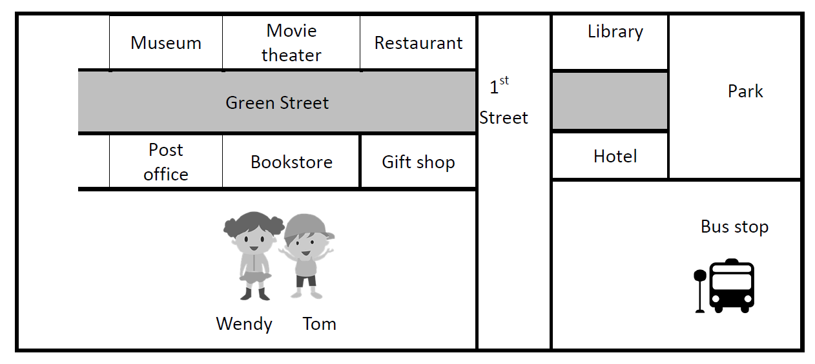
- Where is the movie theater?
(A) It’s next to the hotel (B) It’s next to the post office
(C) It’s next to the bookstore (D) It’s next to the restaurant

- Wendy and Tom are going to the park, which way should they go?
(A) Go straight down the Green street (B) Go straight down the 1st street
(C) Turn right on the 1st street (D) Turn left on the Green Street
- Where is the bookstore?
(A) It’s between the restaurant and the gift shop
(B) It’s between the post office and the gift shop
(C) It’s between the museum and the gift shop
(D) It’s between the library and the hotel
- Wendy and Tom are going to eat dinner, where is the best place to go?
(A) library (B) museum (C) gift shop (D) restaurant
- Wendy and Tom are going to play the kite, where is the best place to go?
(A) bus stop (B) hotel (C) park (D) bookstore

